**HOW TO RUN A CODE:**

First you have to run the first block of the Jupyter note book file which includes the url of the websites. data will be saved in the list in each function. Press the run button to run the code.

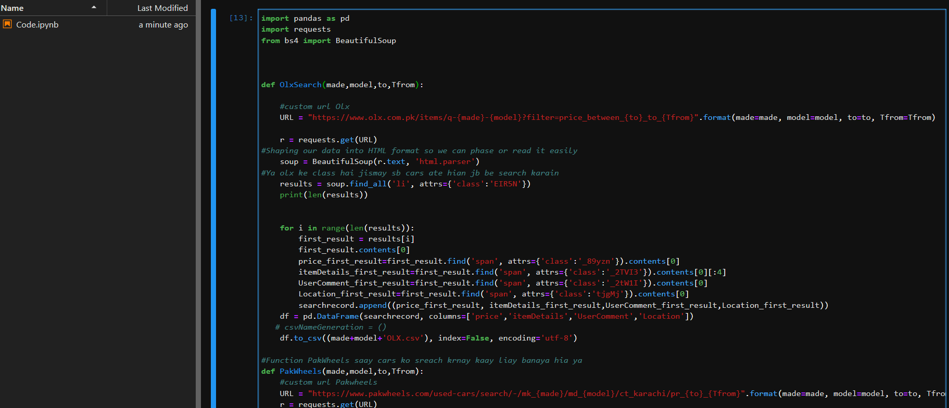

Once the run button is pressed the system will ask the user about the car which they wants to search. As you can see in the screen shot below:

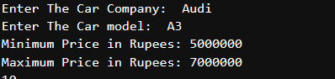

When you give input to the system about your required car it will analyze the data and fetch the selected data from websites and create the .csv file as you can see in the screenshot below. Then you will run the third block of the jupyter note book to generate the pie chart of the .csv file which is just created by the system about your searched car.

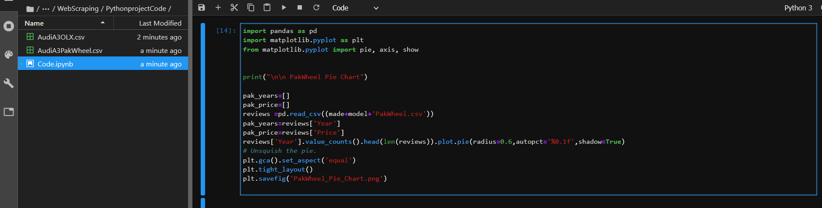

After running the third and the four block of the jupyter notebook you will get the pie chart of the searched car from pak wheels and olx. As you can see in the screenshot below:

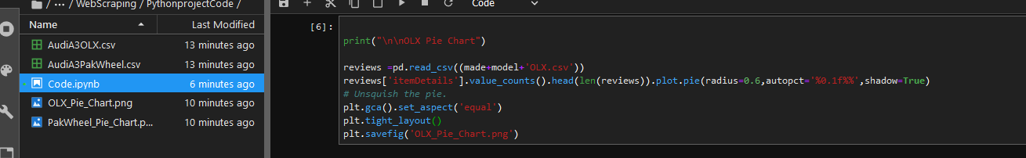

After the generation of the .csv file and pie chart you will run the fifth block of the jupyter note book in which you will generate the .pdf file in which you will get the summary of your search.

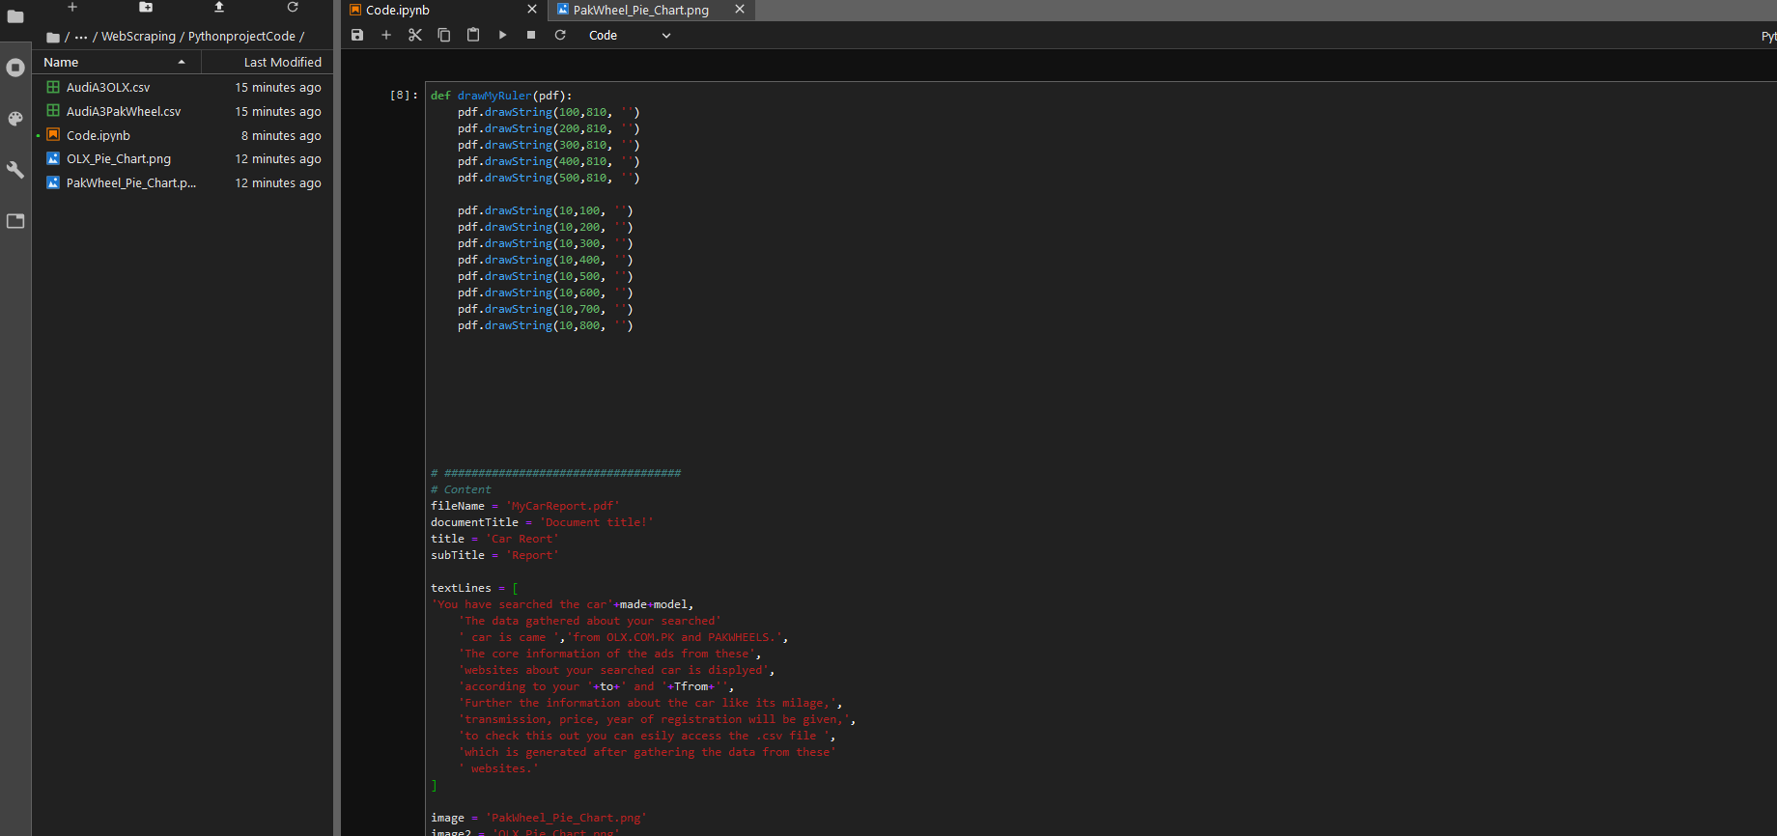

As you can see in the hierarchy MyCarReport.pdf will generate when you will run the fifth block. All the files in the hierarchy are build on run time according to our search data. Code.ipynb is the file which contains all code you can find in the code folder.

